Response to ISRP by Brian Wolcott, Director, Walla Walla Basin Watershed Council
Project Name: Restore Walla Walla River Flow

Project #: 200203600

This project is part of a major thrust by governmental and non-governmental entities to restore habitat and fish in the Walla Walla basin. The project addresses the very important problem of restoring flows to the streams in this basin. To date, the project appears to have been highly successful in enlisting private landowners in water conservation efforts. The approach used in this project should be widely adopted in the Columbia Basin. The sponsors need to discuss whether an effectiveness monitoring plan is in place that will evaluate quantitatively improvements in habitat attributes and fish use in the project reach following restoration actions. Such a plan would demonstrate the value of the fine effort to conserve water undertaken so far by the sponsors.

An effectiveness monitoring plan is in place to monitor this project’s flow improvement changes to the river as part of the USFWS and Irrigation District Settlement Agreement. The initial plan was developed in 2000 and prescribed bi-weekly river flow monitoring at half mile intervals along the four mile rewatered reach between Nursery Bridge and Tumulum Bridge. Water temperature loggers were also installed at each of those locations. The Walla Walla Basin Watereshed Council (WWBWC) managed those sites and compiled the data during the first three years of the agreement. Daily flow monitoring has occurred immediately below nursery bridge to ensure the 25 cfs bypass flows are instream. Increased fish passage and habitat use by summer steelhead and bull trout has been documented by fish ladder video counts. The Confederated Tribes of the Umatilla Indian Reservation have been counting the number of reintroduced spring Chinook adults passing through the rewatered reach, utilizing a video count station built into the Nursery Bridge Fishway structure. The Irrigation districts provided funding for 30 radio tags which were implanted in bull trout as part of a cooperative project with the Watershed Council, OWEB, ODFW, and CTUIR. CTUIR tracked the seasonal movement of those bull trout, some of which utilized, or passed through the rewatered reach. USFWS presence absence studies and video counts at the old Nursery Bridge fish ladder are also tracking bull trout passage. The BPA proposal # 200003900, Walla Walla Subbasin Collaborative Salmonid Monitoring and Evaluation, will continue documenting steelhead and Chinook life history patterns as it tracks fish presence, movement, age class, and population size in the rewatered reach. The BPA proposal # 200734000, A Multidisciplinary, Collaborative Approach to aquatic Habitat Monitoring and Evaluation in the Walla Walla Subbasin, if funded will continue habitat and water quality data collections that WDFW and the WWBWC had been completing on their sides of the Walla Walla Basins stateline.
Technical and scientific background: The problem is well defined and technically justified. The project would ensure increased flow through a normally dewatered reach preventing stranding and improving migratory and juvenile rearing habitat and replenishing subsurface water storage. The technical analysis has led to innovative approaches that have proven to be effective in restoring flows to the Walla Walla River. This should serve as a model for action throughout the Basin.
The sponsors need to provide information on run sizes in the river in which the project is located.

The largest portion of the Walla Walla subbasin wild summer steelhead run passes through the rewatered reach improved by this project with most of the run occurring in April through June as flows subside. The 13 year average from fish ladder counts at the uppermost end of the effected reach averages 500 - 600 adult fish per year, with approximately 4 % of those being of hatchery origin. Juveniles are residing in portions of this rewatered reach all summer.

Adult Spring Chinook were reintroduced into the Walla Walla basin each of the last six years, starting in 2000. Prior to that, a few strays were documented in recent years. Adult reintroduction numbers have varied from 259 up to 1092. Adult to adult replacement values of the 2005 return appear to be nearly 1:1, although some of those fish are likely strays from other subbasins. Tagged smolt releases totaling 250,000 began in 2005. The CTUIR are interested in expanding the Chinook population with a hatchery program upstream of the effected reach. This flow improvement project and associated passage work has given CTUIR staff the confidence that reintroduced spring Chinook will now thrive in the Walla Walla Subbasin.

Dozens of bull trout move through this reach seasonally, with some adults residing at the upper end of the rewatered reach all summer.

They also need to explain why the EDT analysis did not rank the targeted springbrooks as high priority.
The EDT analysis of the targeted spring brooks and their significance is described in Section 3.6.4 of the Walla Walla Subbasin Plan, titled “Divergences from EDT”, starting on page 59. The text specific to the Walla Walla Spring source Creeks and Distributaries begins on page 70.

The spring source and distributaries that enter the Walla Walla in the stateline area south and west of the town of Walla Walla are of special concern in this assessment. These streams include: East Little Walla Walla system; West Little Walla Walla system; McEvoy Creek; and Spring Branch. Of these only East Little Walla Walla came out high for restoration in the EDT analysis and none came out high in protection value. The concern is that the real worth of these streams that have most of their flow from groundwater/springs may not be well expressed in the EDT analysis. Flows are variable in these tributaries, and in the summer they have temperatures that are much cooler than the mainstem. As an example, in 2002 temperatures in E. Little Walla Walla reached only 70 degrees F; temperatures on the mainstem Walla Walla at Mojonnier Rd (less than 1 mile downstream) exceeded 75 degrees F (Mendel et al. 2003). In all likelihood these streams offer refuge for juvenile salmonids, both within the streams and at the mouths, from the higher temperature mainstem. These spring source creeks are impacted by water
diversion activities in Oregon. The West and East Little Walla Walla are influenced by the Little Walla Walla diversion off of the mainstem Walla Walla. Water that is diverted from the mainstem Walla Walla but is not used by irrigators on the Little Walla Walla Walla ends up in the East and West Little Walla Walla Rivers. In recent years less water has been diverted down the Little Walla Walla in the summer to satisfy a minimum instream flow requirement on the mainstem Walla Walla River. Because less water has been diverted ino the Little Walla Walla, less water has been available for the West and East Little Walla Walla Rivers as well. While East Little Walla Walla can maintain flow due to groundwater influence the West Little Walla in Washington has gone dry the past three summers.

The influence that these streams can have on the steelhead and Chinook salmon populations is largely unknown. The assumption for this assessment is that the cool water input to the mainstem and opportunity for refuge should not be ignored. All of the the streams, with the exception of West Little Walla Walla, flow into geographic areas that are priority for restoration and protection and that have flow and temperature as limiting factors. West Little Walla Walla flows into the Walla Walla just downstream of the priority geographic areas. Given the complicated nature of this area, not to mention the bi-state implications, this assessment recommends that the combined citizen and technical groups consider the issue for inclusion within the management plan.”
Rationale and significance to subbasin plans and regional programs: This project would be a part of an apparently successful restoration program for the Walla Walla basin with good cooperation from landowners. The project area is identified as a priority in the Walla Walla Subbasin Plan and the proposal addresses priority strategies. The project could benefit anadromous as well as resident ESA listed species. It also addresses objectives in the Fish and Wildlife Program.
Relationships to other projects: The project is related to several BPA funded project as well as to numerous other state, federal, and privately funded projects. A major strength of the proposal is the collaboration with private landowners who have worked closely with the sponsors to provide increased flow to benefit fish.
Project history: The project history documents the success of the approach used by this project but provides no data documenting improved instream flows relative to pre-project conditions.
Improved instream flows are apparent in the following diagram showing the pre flow improvement reach at half mile intervals before and during the agreement. The decrease in flows in the half-mile between M-5 and M-6 is a result of riverbed seepage. Less than 1 cfs of irrigation withdrawals occurs in the 3-mile reach described in the graph.

The next diagram from the Walla Walla Temperature TMDL assessment shows how those increased flows have improved summer temperatures

River mile 42 – 49 is the reach most impacted by the flow and temperature improvement.
Objectives: The project has one objective, which is to increase summer flows by 10-15%. Does this flow increase pertain to the three-mile reach north of Milton-Freewater? Is the percent increase over and above the 25 cfs already provided? Quantitatively (as well as possible), how much habitat improvement can be expected from such a small increase in flow? Should there be an objective for aquifer recharge?
The objective is to legally protect an additional 10-15% of the conserved water that is being left in stream. Currently completed conservation projects can only be used to protect 10-15 cfs of the 25 cfs that is being bypassed. This project will allow the irrigators to attach the remaining flows to additional water conservation. Currently they are bypassing water rights that they have to backfill with unsustainable groundwater pumping to keep farming. This project will reduce the increased demand on groundwater pumping and help the Milton-Freewater area irrigators protect up to 25 cfs of their bypassed river flows from junior appropriation upstream or downstream. This will ensure the three mile rewatered reach remains flowing all summer, and that the improved flow that their bypass has caused as far as eighteen miles downstream will remain instream and become dependable steelhead habitat. The habitat improvement along that formally dry and now rewatered reach is sufficient to provide year round habitat for steelhead. The low flow section of the river for the next fifteen miles has also had more flows and cooler temperatures except where some groundwater retun pockets were overwhelmed with warmer surface flows.

The objective for the aquifer recharge is to restore the shallow aquifer water table and down gradient spring creeks.

This proposal should be linked to the Columbia Basin Water Transaction Program (proposal 200201301) and address the criteria for water transactions under that program that are relevant to the proposed actions.
The two irrigation Districts involved in this project have been negotiating with staff from the Columbia Basin Water Transactions Program (CBWTP) for the portion of water conserved back to the river that is from their own cash and labor and independent of state, BPA, or Federal assistance. The scale of the efficiency projects makes it difficult to depend solely on the hope that after the water conservation work, that the CBWTP will provide enough of the funding to pay off bank loans. The CBWTP does not assist with up-front construction costs. An individual farm conserved water project within the overall conservation effort met all CBWTP criteria and received funding

Tasks (work elements) and methods: Strategies for accomplishing the objectives rather than specific methods are given. This is understandable given the nature of the project. The sponsors should explain the methods by which aquifer recharge will be accomplished.

The WWBWC has been implementing a shallow aquifer recharge project under an experimental limited license from Oregon Water Resources Department. Recharge started in the Spring of 2004, utilizing high spring runoff coming down the river , sending it down one of Hudson Bay District Improvement Company’s irrigation delivery ditches to a leased farm where three infiltration basins were dug in area with coarse gravel beds and a depth to water table that would permit the influx of water. Preliminary monitoring in adjacent and down-gradient wells, and springs have shown direct improvement to the groundwater table and to increased flow from springs and the creeks they feed, some of which are headwaters of steelhead streams such as Mud Creek, Schwartz Creek, and lower Pine Creek. This project would expand the existing Recharge site and also fund the development of an additional site on the valley floor in closer proximity to the seasonally low flow reach of the Walla Walla River and the Little Walla Walla River. this project would also fund seasonal monitoring of the Little Walla Walla River system to track passive recharge and hyporheic exchange occurring along that distributary in relation to irrigation delivery and irrigation efficiency changes.
Monitoring and evaluation: The major drawback of this proposal is the lack of a consolidated monitoring program to assess the effectiveness of the water conservation strategies in improving flows, aquifer recharge and springbrook flows, fish habitat characteristics (e.g. pool depth, stream temperature) and fish use. Some monitoring activities are discussed at various points in the proposal but the total program (design, methods, metrics, etc.) is not presented.
A comprehensive hydrologic monitoring program has been occurring in the vicinity of this project, however most of it has been receiving funds from OWEB, ODEQ, NRCS and WDOE. This monitoring has been looking at surface water groundwater interactions in the Walla Walla Valley in relation to irrigation efficiency and Little Walla Walla River distributary flows transferred over to the mainstem Walla Wala River as part of the USFWS Walla Walla Irrigation Settlement Agreement.

The following three diagrams show the typical years hydrology and water quality monitoring network completed by multiple organizations utilizing state, federal, and BPA funding.

Figure 2 shows the surface water groundwater hydrlogy monotioring network that has been developed by the WWBWC in cooperation with Oregon Water Resources Dept.

The third image shows the CTUIR habtiat survey work completed by CTUIR fisheries staff on the effected river reach and creeks.

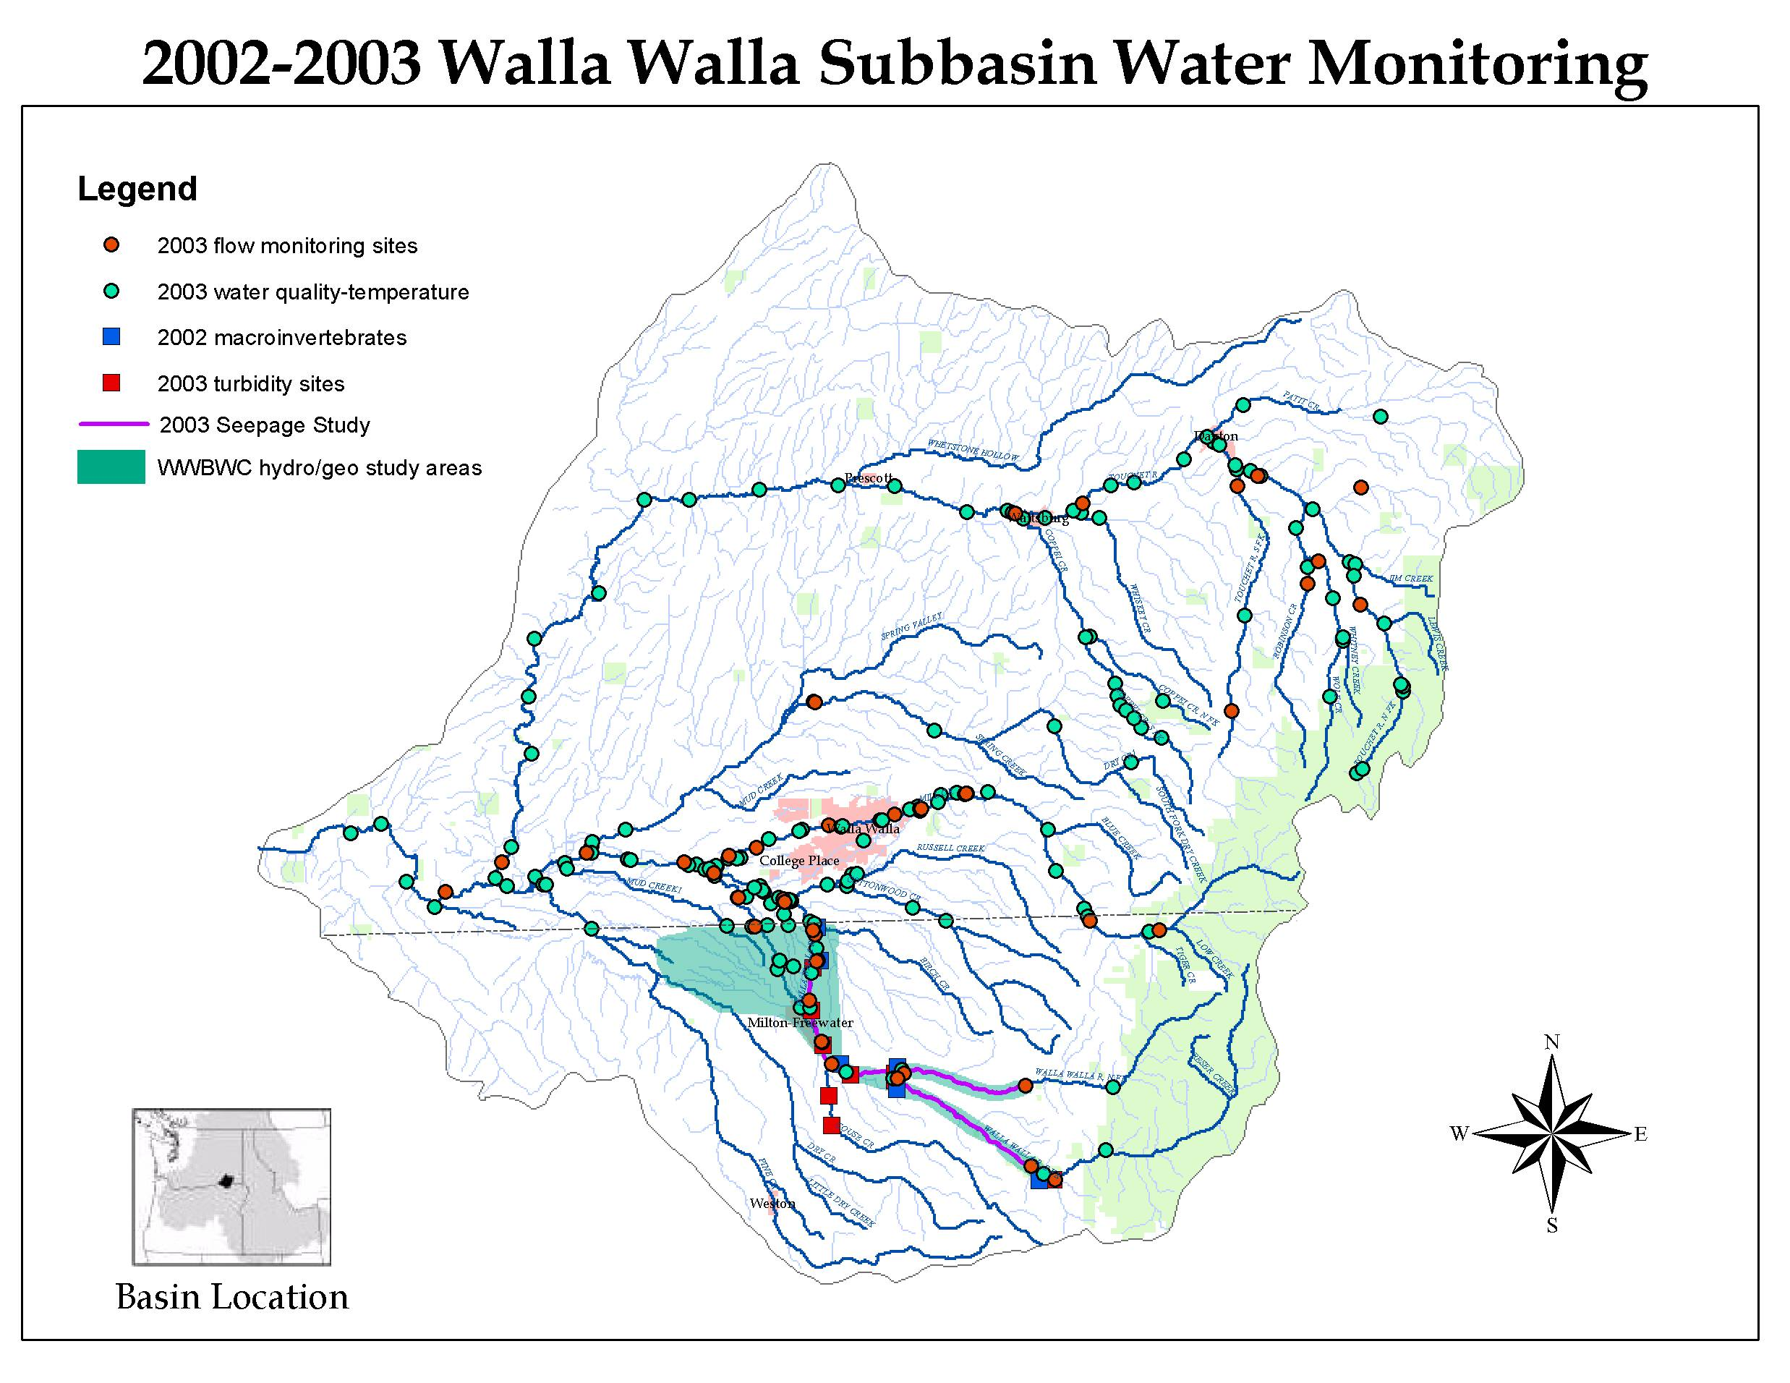

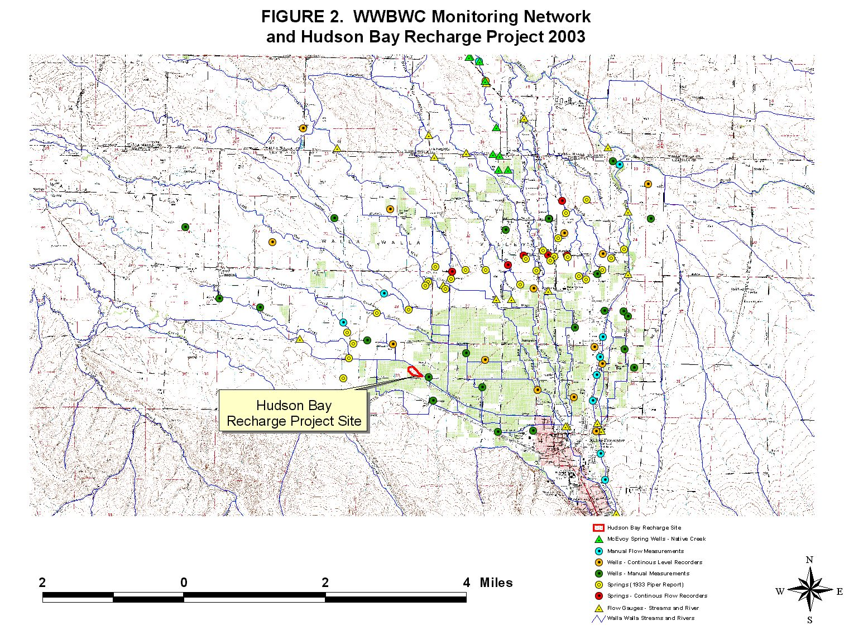
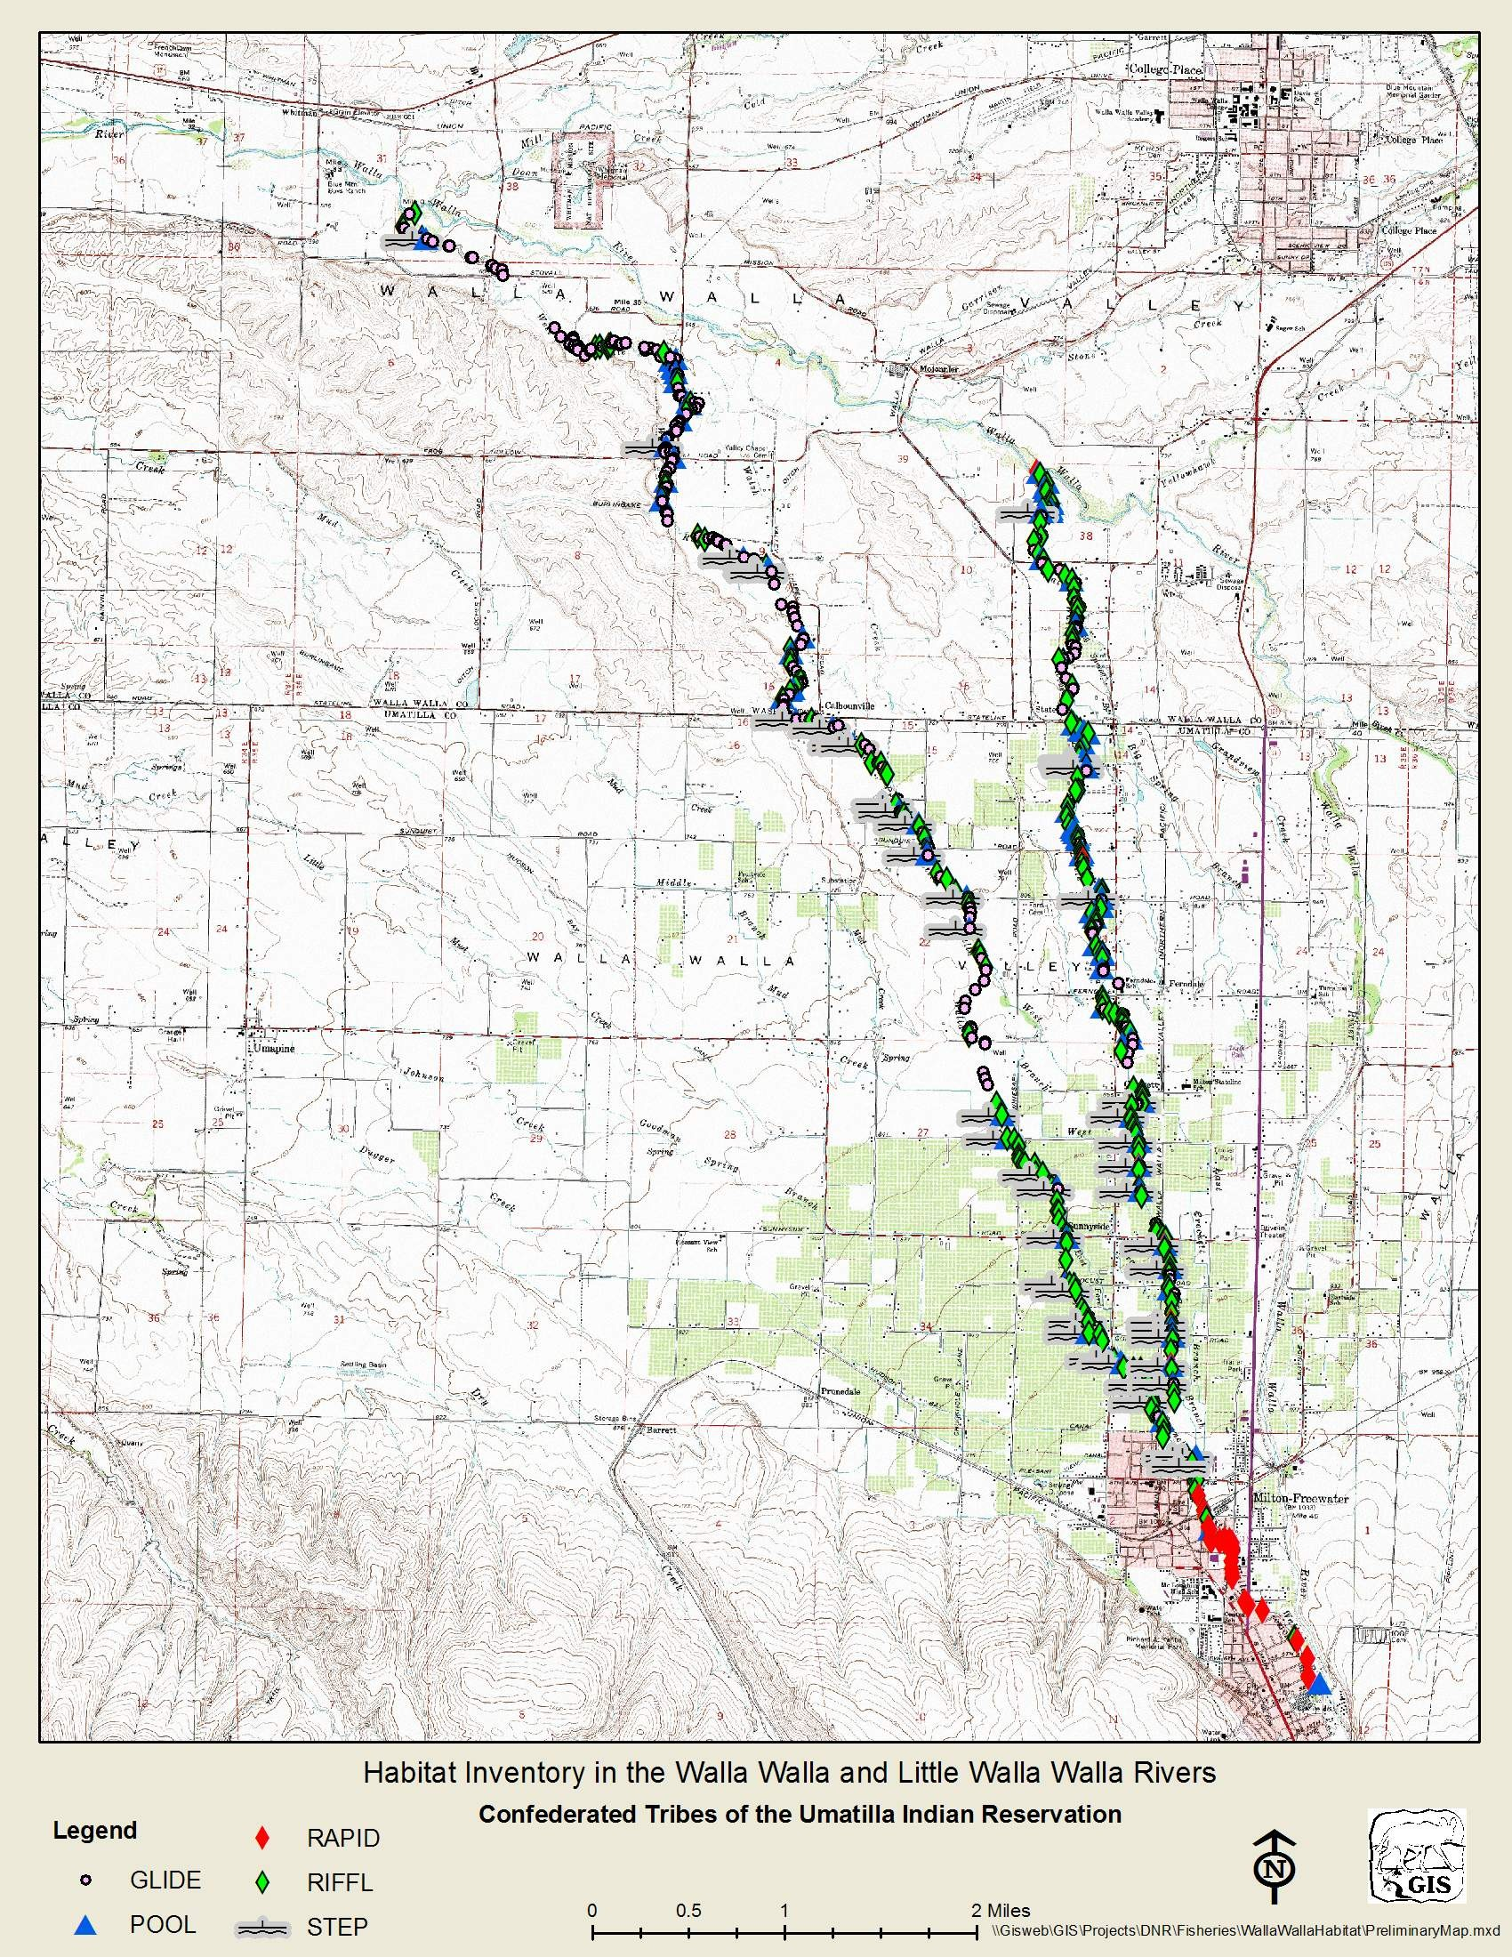

Facilities, equipment, and personnel: Facilities are adequate, and personnel are well qualified. Have the sponsors been receiving advice from a fisheries biologist?
The District fish biologists from ODFW and WDFW, along with fisheries biologists from CTUIR have assisted with prioritizing this project, monitoring resulting improvements to river and creek habitats, and assisted with permitting.
Information transfer is not discussed.
In addition to information updates at our monthly watershed meetings, seasonal Walla Walla Technical Work Group meeetings, growers seminars, and field tours, we will be posting project information and updates on our website (www.wwbwc.org) and in our quarterly watershed newsletter. We also continue to work with the local newspapers to ensure that information and project updates are relayed to the public in a timely manner.
Benefits to focal species: The benefits of increasing instream flow could be significant for a number of focal species, but the sponsors provide no estimate of how flow improvements will affect habitat attributes (other than flow and temperature) and fish use. Effectiveness monitoring would help to address these questions.
In addition to this project providing protected flows and the resulting improved temperatures for the 3 mile rewatered reach and improved flows for fifteemn miles downstream, this project also provides passage flows necessary for steelhead, spring Chinook, and migratory bull trout to reach the high quality spawning and rearing habitat in the upper Walla Walla River.
Benefits to non-focal species: The project could benefit non-focal species by improving habitat. The sponsors have already demonstrated an increase in macroinvertebrates, an important food resource for juvenile salmon.

This project improves flows, temperatures, and passage for the rainbow trout, mountain whitefish, brook lamprey, potentially existent pacific lamprey, margined sculpin (state species of concern) that utilize the effected reach of the Walla Walla River.

The final two photos below show the rewatered section before and after the first phase of this project.

The Walla Walla River in August 1999 bone dry as it had been each summer for over 100 years.

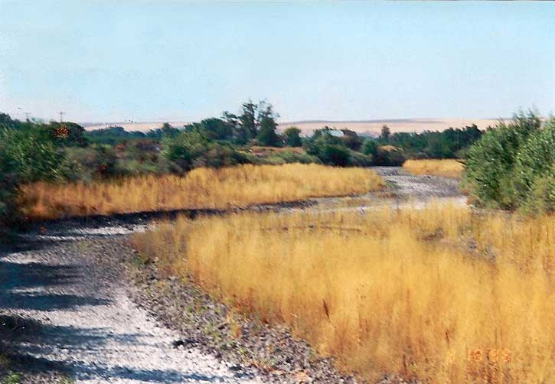

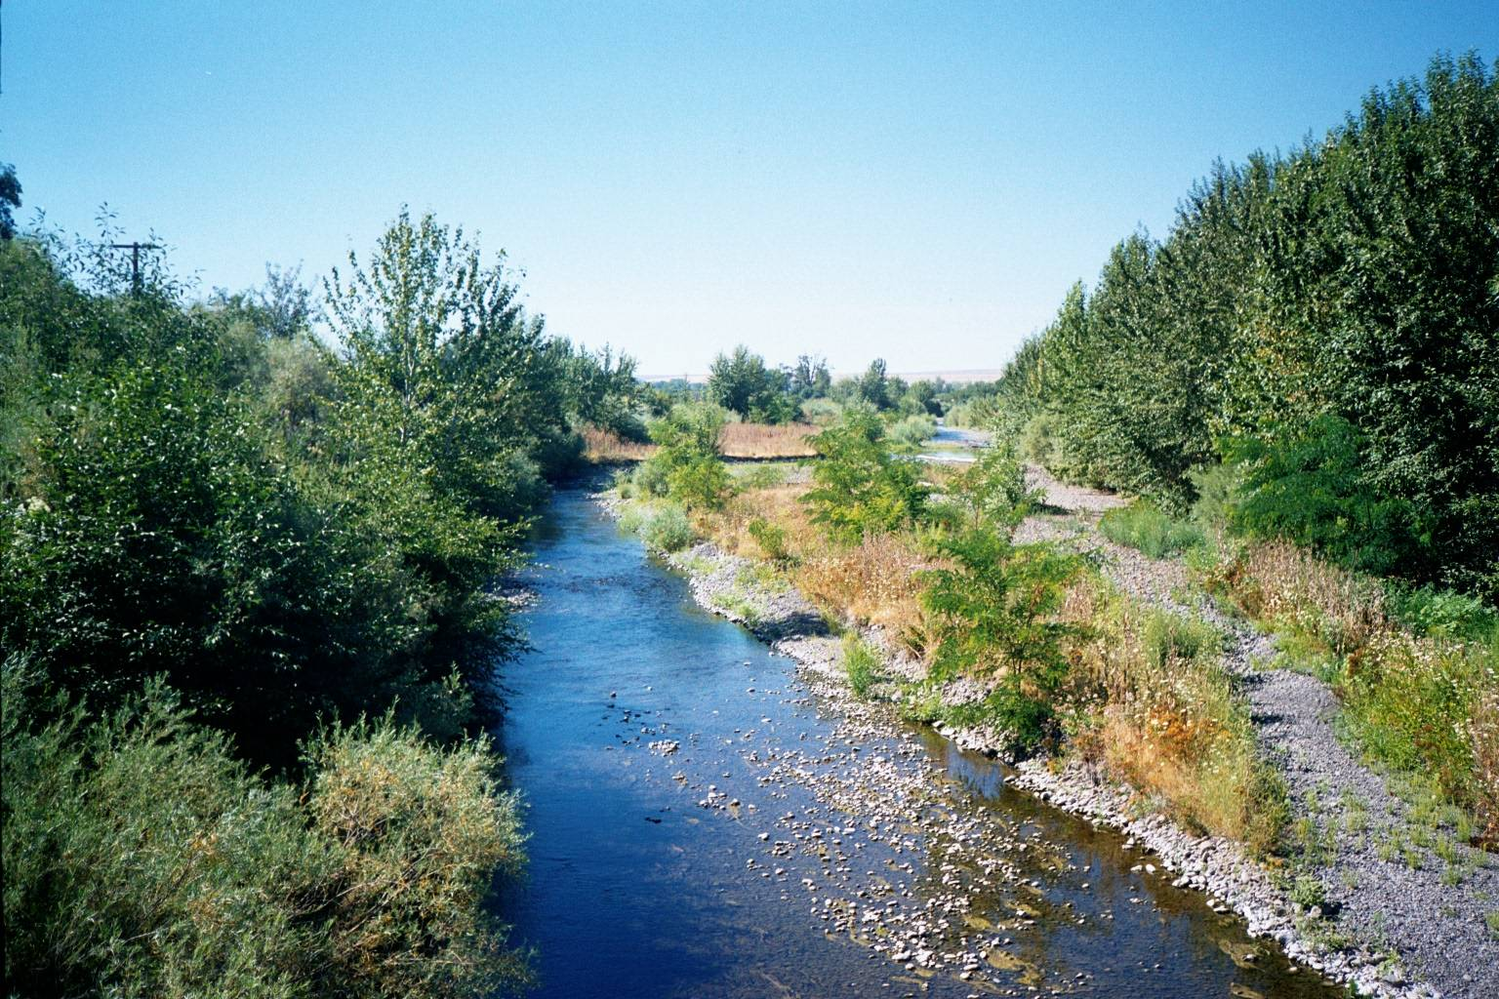
The same section of the Walla Walla River (RM 42) with restored flows in August 2002.

